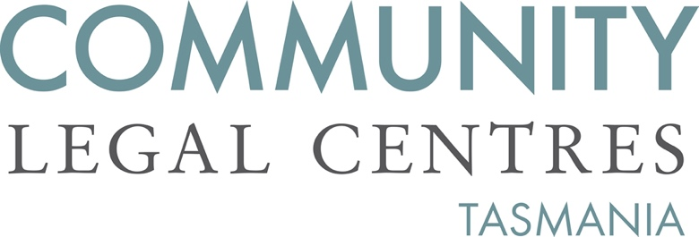

14 February 2023

Department of Justice
Office of the Secretary
GPO Box 825
Hobart TAS 7001

via email: haveyoursay@justice.tas.gov.au

To the Department of Justice,
Re: Police Offences Amendment (Nazi Symbol Prohibition) Bill 2023

Community Legal Centres Tasmania (CLC Tas) welcomes the opportunity to provide a response to the Police Offences Amendment (Nazi Symbol Prohibition) Bill 2023.

CLC Tas is the peak body representing the interests of nine community legal centres (CLCs) located throughout Tasmania. We are a member-based, independent, not-for-profit and incorporated organisation that advocates for law reform on a range of public interest matters aimed at improving access to justice, reducing discrimination and protecting and promoting human rights.

We support the Bill’s intention to amend the Police Offences Act 1935 and criminalise the display of Nazi symbols which are hateful and threatening to members of the Jewish community as well as other minority groups persecuted by the Nazi regime including people with disabilities and homosexuals. The display of Nazi symbols is also incompatible with modern Australian community values including multiculturalism.

‘Nazi symbols’
Nazi symbols have been prohibited in France, Austria and Germany for decades. In Australia, In May 2022, Victoria was the first Australian jurisdiction to ban public displays of Nazi symbols with the passing of the Summary Offences Amendment (Nazi Symbol Prohibition) Bill 2022. More recently, New South Wales has also passed the Crimes Amendment (Prohibition on Display of Nazi Symbols) Bill 2022. Queensland’s Premier Annastacia Palaszczuk has announced her intention to table a Bill in the Queensland Parliament later this year.

We support the Bill’s use of the term ‘Nazi symbol’. Deliberately not defining the term ensures that the offence is broad enough to capture traditional well-known symbols such as the ‘Hakenkreuz’ as well as more obscure symbols, newer symbols adopted by Neo-Nazi groups and to adapt to changing symbols.

However, it must be acknowledged that the swastika is also a sacred symbol for members of the Hindu, Buddhist and Jain religions. We strongly support the recognition in clause 4(2) that “the display of a swastika in connection with Buddhism, Hinduism or Jainism does not constitute the display of a Nazi symbol”.

‘Public act’
Clause 4 of the draft Bill provides that “a person must not, by a public act… display a Nazi symbol if the person knows, or reasonably ought to know, that the symbol is a Nazi symbol”. Although the Bill defines ‘public act’ broadly as “any form of communication to the public” and “any conduct observable by the public” we believe that further clarification can be provided on the forms of communication and conduct captured by the offence. A good example is set out in section 93Z of the Crimes Act 1900:

public act includes—

- any form of communication (including speaking, writing, displaying notices, playing of recorded material, broadcasting and communicating through social media and other electronic methods) to the public, and
- any conduct (including actions and gestures and the wearing or display of clothing, signs, flags, emblems and insignia) observable by the public, and
- the distribution or dissemination of any matter to the public.

For the avoidance of doubt, an act may be a public act even if it occurs on private land.

‘public purpose’
The draft Bill provides that a Nazi symbol must not be displayed “without a legitimate public purpose”. The proposed section 6C(3) defines a legitimate public purpose as including academic, artistic, religious, scientific, cultural or educational purposes. We believe that a legitimate public display of a Nazi symbol may be for historical reasons. Although it is arguable that this may be captured in the already prescribed academic or educational purposes, for the avoidance of doubt we recommend that the list of public purposes include ‘historical’.

Search powers
The proposed section 6(4)(a) and (b) of the draft Bill provides police officers with broad powers to search any person, vehicle or residence where they have “reasonable grounds” to believe that the person has displayed a Nazi symbol. The infringement of civil liberties and the associated need for such invasive powers to be afforded to police without a warrant ought not be taken lightly and certainly not in the absence of data evidencing a need for such invasive powers. We recommend that the draft Bill adopt the more balanced approach adopted in Victoria, where police are granted the power to issue ‘Directions to remove Nazi Symbols from public display’ but maintains the need for search warrants by a Magistrate pursuant to the Crimes Act 1958 (Vic).

Education campaign
Whilst we support the Bill it is strongly recommended that the ban is supported by a community education campaign to raise awareness of the origins of the religious and cultural swastika, its importance to the Buddhist, Hindu and Jain communities and the distinction with the Nazi symbol. An education campaign will also hopefully foster the strengthening of multiculturalism and respect for diversity.

Finally, we would recommend that the Government task an organisation like Equal Opportunity Tasmania with monitoring the public display of other hateful symbols and where appropriate to determine whether they too should be prohibited.

If we can be of any further assistance, please do not hesitate to contact us.

Yours faithfully,

Benedict Bartl
Policy Officer
Community Legal Centres Tasmania

Queensland Government, ‘Queensland to make public display of hate symbols a crime’, 26 May 2022. As found at https://statements.qld.gov.au/statements/95214 (Accessed 13 February 2023).
Clause 4 of the Police Offences Amendment (Nazi Symbol Prohibition) Bill 2023.
Section 41L of the Summary Offences Amendment (Nazi Symbol Prohibition) Act 2022 (Tas).

