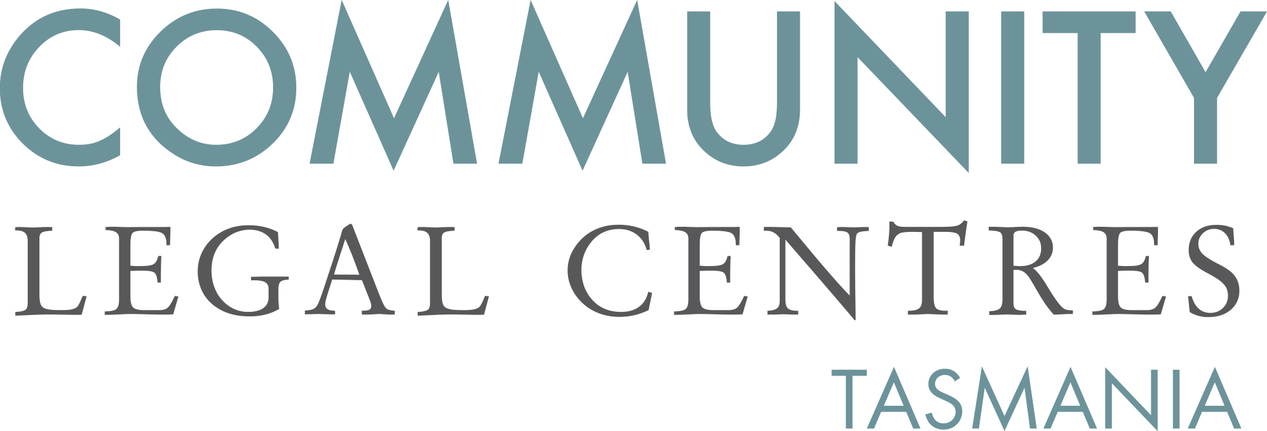

11 October 2019

Tasmania Law Reform Institute
Private Bag 89
HOBART TAS 7001
attn: Jemma Holt

via email: law.reform@utas.edu.au

Dear Jemma,
Re: Jurors, Social Media and the Right of an Accused to a Fair Trial Issues Paper

Community Legal Centres Tasmania (CLC Tas) welcomes the opportunity to respond to the Tasmania Law Reform Institute’s Jurors, Social Media and the Right of an Accused to a Fair Trial Issues Paper (‘the Issues Paper’).

CLC Tas is the peak body representing the interests of nine community legal centres (CLCs) located throughout Tasmania. We are a member-based, independent, not-for-profit and incorporated organisation that advocates for law reform on a range of public interest matters aimed at improving access to justice, reducing discrimination and protecting and promoting human rights.

Internet and social media
We strongly support the right of an accused to a trial before an impartial jury that makes its determination in accordance with evidence properly admitted and tested during the course of the trial. In our opinion, the use of extraneous material including the Internet and social media undermines the fairness of the trial, leading to unfair outcomes and further delay as verdicts are challenged. This view is highlighted in an Australian study carried out in 2013 which surveyed a number of experts working in the field of judicial administration, including judges and magistrates. The survey found that the most significant concern expressed was ‘juror misuse of social media (and digital media) leading to aborted trials’.

The concern that extraneous material may lead to an unfair outcome is reinforced in evidence from overseas. In the United States for example, a review of case law identified at least 90 verdicts between 1999 and 2010 which resulted in mistrials, appeals and overturned verdicts, in whole or in part, because of juror actions related to the Internet. Whilst in the United Kingdom, the Law Commission has identified at least 21 appeals since 2005 related to juror misconduct during criminal trials, some of which involved Internet access or social media use.

In Tasmania, measures have been put in place to mitigate against the use of extraneous material. For example, the Supreme Court does not permit jurors to have their mobile phones with them during the trial or deliberations and comments on passing sentence are temporarily removed from the Supreme Court database when an accused is on trial for new offences. Nevertheless, we believe that more can be done, particularly as jurors are not sequestered for the length of the trial and therefore have access to the Internet and social media overnight.

Whilst the High Court has held that directions given by the trial judge are sufficient to relieve against the unfair consequences of pre-trial publicity we believe that directions can be improved, to expressly include the use of social media. Currently, Tasmania does not have model directions, meaning that trial judges may make different directions about jurors use of the Internet and social media. In our opinion, directions about the use of the Internet and social media should be standardised as has occurred in New South Wales and Victoria. A good example is New South Wales where Model Directions include a warning to jurors to not use the Internet to research any matter related to the trial:

You should keep away from the internet and the other communication sources which may pass comment upon the issues in this trial. You may not communicate with anyone about the case on your mobile phone, smart phone, through email, text messaging, or on Twitter, through any blog or website, any internet chatroom, or by way of any other social networking websites including Facebook, MySpace, LinkedIn and YouTube. You should avoid any communication which may expose you to other people’s opinions or views.

As well as standardised oral directions being provided by the trial judge, we strongly believe that these should be supplemented with written directions, which either reproduce the oral directions, or are provided in addition to the oral directions. Support for this reinforcement is found in a study which found that written directions are almost twice as effective as oral directions.

We also support, as has been recommended by some academics, the implementation of low cost and low interference measures that reinforce the need to remain impartial including written signs, posters and other visual aids in the jury room and/or court precinct.

Juror Misconduct
As well as the unlawful use of the Internet and social media during a trial, juror misconduct may also include seeking to influence other jurors. In our opinion, measures should be implemented to ensure that jurors are able to easily report incidents of juror misconduct. An easy to follow process for reporting juror misconduct is likely to deter jurors from engaging in misconduct due to the risk of detection as well as increasing the chance that jurors do not share the results of their misconduct with other jurors. With research from the United Kingdom demonstrating that almost half of all jurors are unsure what to do if something improper occurred during jury deliberations we believe that current procedures should be reviewed. Options that could be considered include the installation of a box in the vicinity of the jury room that notes could be dropped into, a hotline that people could call or an email address that anonymous information could be sent to.

If we can be of any further assistance, please do not hesitate to contact us.

Yours faithfully,

Benedict Bartl
Policy Officer
Community Legal Centres Tasmania

Murphy v R (1989) 167 CLR 94 at 98–99 per Mason CJ and Toohey J.
Patrick Keyzer, Jane Johnstone, Mark Pearson, Sharon Rodrick and Anne Wallace, ‘The courts and social media: what do judges and court workers think?’ (2013) 25(6) Judicial Officers’ Bulletin 47.
Ibid at 48.
Brian Grow, ‘As jurors go online, US trials go off track’, Reuters, 9 December 2010. As found at http://www.reuters.com/article/2010/12/08/internetInternet-jurors-idUSN0816547120101208 (Accessed 8 October 2019).
United Kingdom Law Commission, Contempt of Court: A Consultation Paper (Consultation Paper No 209: 2012) at 62.
Supreme Court of Tasmania, ‘First Day of Trial’. As found at https://www.supremecourt.tas.gov.au/jurors/first-day-trial/ (Accessed 8 October 2019).
Dupas v The Queen (2010) 241 CLR 237 at 247.
Judicial Commission of New South Wales, Criminal Trial Courts Bench Book (December 2018) part 1-490. Also see Judicial College of Victoria, Criminal Charge Book, part 1.11.
Cheryl Thomas, ‘Are Juries Fair?’ (Ministry of Justice, Research Series 1/10: 2010) at 38-39. See also Jill Hunter, UNSW Jury Study: Jurors’ Notions of Justice: An Empirical Study of Motivations to Investigate & Obedience to Judicial Directions (2013) recommendation 4.
Meghan Dunn, Jurors’ and Attorneys’ Use of Social Media During Voir Dire, Trials, and Deliberations: A Report to the Judicial Conference Committee on Court Administration and Case Management (Federal Judicial Center: 2014) at 10. Also see Marilyn Krawitz, ‘Guilty As Tweeted: Jurors Using Social Media Inappropriately During the Trial Process’ (University of Western Australia, Faculty of Law Research Paper No 2012-02: 2012) at 35.
Cheryl Thomas, ‘Are Juries Fair?’ (Ministry of Justice, Research Series 1/10: 2010) at 39.

