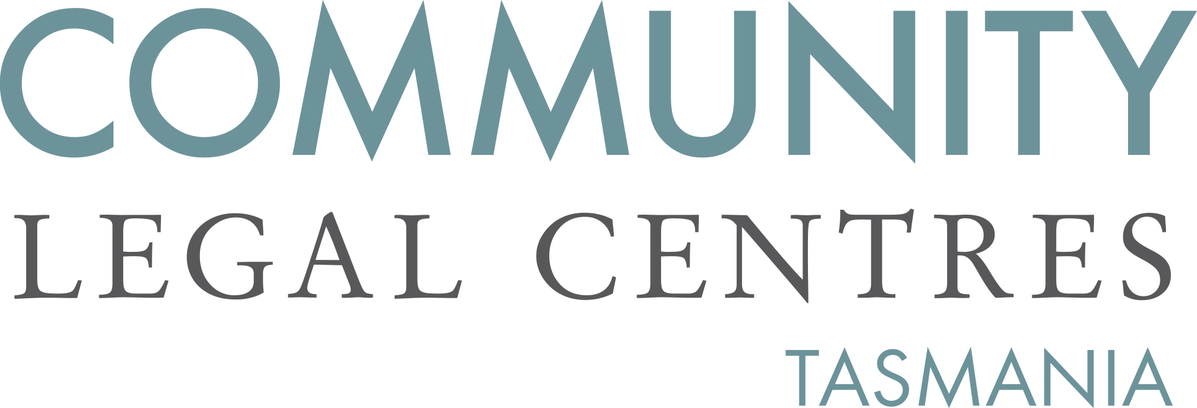

2 August 2019

Department of Justice
Office of the Secretary
GPO Box 825
Hobart TAS 7001
via email: haveyoursay@justice.tas.gov.au

To Julian Vittorio,
Re: Justice Legislation Organisational Liability for Child Abuse Amendment Bill 2019

Community Legal Centres Tasmania (CLC Tas) welcomes the opportunity to provide comment on the Justice Legislation Organisational Liability for Child Abuse Amendment Bill 2019 (‘the draft Bill’).

CLC Tas is the peak body representing the interests of nine community legal centres (CLCs) located throughout Tasmania. We are a member-based, independent, not-for-profit and incorporated organisation that advocates for law reform on a range of public interest matters aimed at improving access to justice, reducing discrimination and protecting and promoting human rights.

We are supportive of the Government’s intention to implement a number of recommendations from the Royal Commission into Institutional Responses to Child Sexual Abuse (‘the Royal Commission’). In particular, we are supportive of the draft Bill’s intent to enhance access to justice for survivors of child sexual abuse and ensure that organisations do everything in their power to prevent child sexual abuse from occurring.

Limitations Act 1974 (Tas)
Many survivors of child sexual abuse are reluctant to disclose the crimes perpetrated against them until many years have passed. For example, the Royal Commission found that survivors of institutional child sexual abuse take, on average, 24 years to disclose the crime. As well, knowmore, a nation-wide community legal centre providing legal advice and information to survivors of child abuse, has reported that approximately 83 per cent of clients are 46 years of age or older. As such, it is important that the Limitations Act 1974 (Tas) be amended to allow survivors of child sexual abuse to bring civil actions against their perpetrators, even in circumstances where decades may have elapsed.

The Tasmanian Government is to be commended for having amended the Limitations Act 1974 (Tas) in 2017 so that civil actions for both sexual abuse and serious physical abuse committed against a minor “may be brought at any time”.

Nevertheless, it is clear that in the past, the Limitations Act 1974 (Tas) has acted as a significant barrier for survivors of child sexual abuse in their efforts to obtain appropriate compensation for the harm inflicted. Anecdotally, we have been informed that many survivors felt coerced into settling claims on terms manifestly inadequate to them. This was because it was made clear to the survivors that if they did not accept the compensation offered, any claim would be vigorously defended and would almost certainly fail due to the significant hurdle of the Limitations Act 1974 (Tas).

We strongly support the inclusion of clause 5C in the draft Bill. In our opinion, allowing courts to set aside a previous settlement between an organisation and a survivor “if it is in the interests of justice to do so” provides the necessary balance between a defendant’s need for finalisation and the claimant’s demonstrable claims that a settlement was either unfair or inappropriate. However, for national consistency, we believe that the draft Bill should consider applying the same ‘just and reasonable’ wording as that adopted in other jurisdictions including Queensland and Western Australia.

In Queensland, where similar amendments have already been passed, case law already provides some guidance on the circumstances in which it would be ‘just and reasonable’ to set aside a previous agreement. In TRG v The Board of Trustees of the Brisbane Grammar School a survivor who was sexually abused by a school counsellor in the 1980s received a payout of $47,000 after reaching a private settlement with the respondent in 2002. Fifteen years later, after the Queensland Government amended the Limitations of Actions Act 1974 the survivor sought to bring a fresh appeal to the court to have the agreement between him and the respondent set aside. Justice Davis found that a number of factors needed to be considered including:

- The prospects of success in any claim; and
- The quantum of any claim brought now; and
- The effect of the Limitations Act on the quantum of the original settlement; and
- The reasonableness of the mediation process; and
- The reasonableness or otherwise of the settlement figure; and
- The impact of delay; and
- Costs already paid; and
- Loss of insurance; and
- The offer of ongoing counselling.

Importantly, clause 5C of the draft Bill is worded broadly and does not exclude any of the factors raised by the Supreme Court of Queensland being taken into account in determining whether the previous agreement should be set aside.

Resourcing
To ensure that all relevant organisations are made aware of the need to do everything in their power to prevent child sexual abuse from occurring and to inform persons who use their services of their rights, we strongly recommend that a widely disseminated information campaign take place. This information campaign should also apply to the national redress scheme. Finally, we strongly recommend that legal assistance services are appropriately funded so that all survivors of child sexual abuse can make an informed decision about either pursuing civil litigation or accessing the redress scheme.

If you have any queries or we can be of any further assistance, please do not hesitate to contact us.

Yours faithfully,

Benedict Bartl
Policy Officer
Community Legal Centres Tasmania

CLC Tas would like to acknowledge knowmore for its assistance with this response.
Royal Commission into Institutional Responses to Child Sexual Abuse, Final Report, Volume 4, Identifying and Disclosing Child Sexual Abuse (December 2017) at 9.
Knowmore, National Redress Scheme Infographic (June 2019). As found at https://knowmore.org.au/wp-content/uploads/2019/08/12.-Redress-Scheme-Infographic-June-2019.pdf (Accessed 31 July 2019).
Section 5B(1) of the Limitations Act 1974 (Tas).
[2019] QSC 157. Also see JAS v Trustees of Christian Brothers [2018] WADC 169 in which the respondent did not oppose the application.
[2019] QSC 157 at paras [161]-[271].

