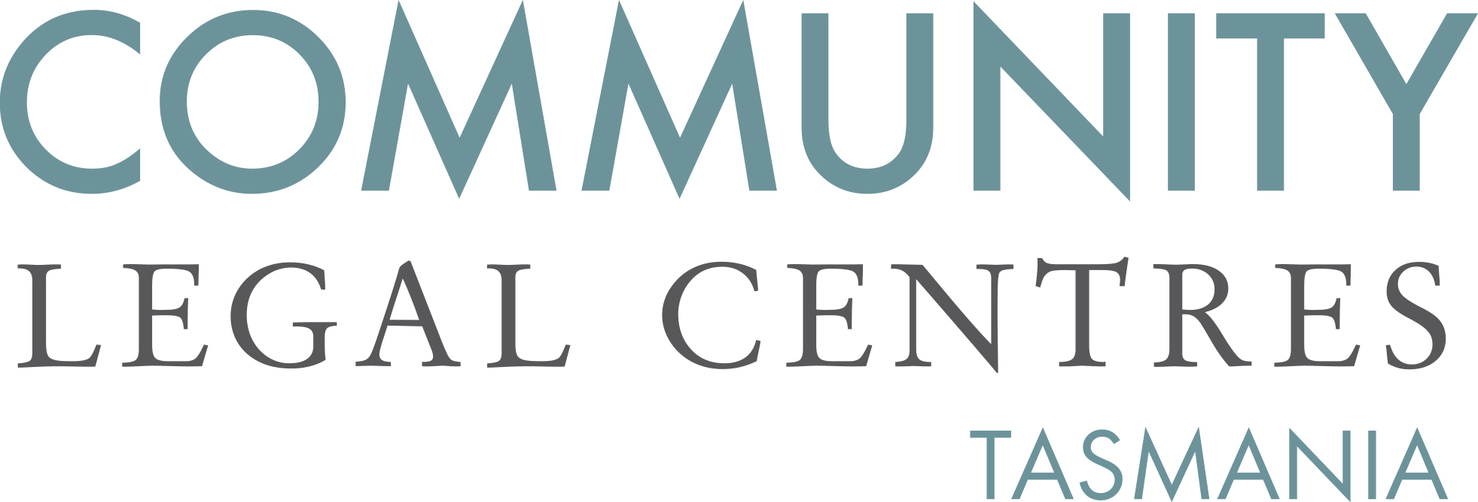

MEDIA RELEASE

Coalition of community groups call for $2 million injection of funding for drug treatment
9th September 2016

A coalition of community groups including community, civil society organisations and unions have today written to the State Government commending them on proposed sentencing reforms but expressing their alarm that no additional funding will be provided for the introduction of programs likely to cost in excess of $2,000,000.00.

Jane Hutchison, Chair of CLC Tas said:

We welcome the State Government’s commitment to addressing the causes of offending behaviour through the expansion of drug treatment orders and the introduction of deferred sentencing. However, drug treatment and other rehabilitation programs are costly and the Government must be prepared to have the courage of its convictions and provide proper funding.

The letter to the Attorney-General comes on the back of research carried out by CLC Tas and provided to the Department of Justice as part of the consultation into the Sentencing Legislation Amendment Bill 2016 demonstrating that there are around 70 offenders sentenced in the Supreme Court each year who will be eligible for drug treatment orders.

Benedict Bartl, CLC Tas policy officer said:

More than 70 offenders sentenced in the Supreme Court each year can trace their offending back to problematic drug use. A properly funded drug treatment program is likely to be a win-win-win with the offender undergoing treatment for their addiction, the community safer as a result of reduced recidivism and our prisons less full.

The call for funding comes after the Attorney-General made clear that no additional funding would be provided during 2016-17 and despite the Sentencing Advisory Council having called the reforms ‘resource intensive’.

A copy of the letter is attached.

For more information:
Jane Hutchison – 0417 596 919 Benedict Bartl – 0417 032 832

Attorney-General Vanessa Goodwin, Legislation to implement new sentencing options, Media Release 23 August 2016.

